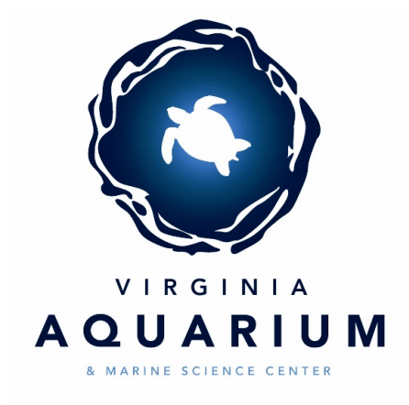
Virginia Aquarium and Marine Science Center

Citizen Water Quality Monitoring Program
What’s in your water? Find out at the Virginia Aquarium!

The Virginia Aquarium Water Quality Lab performs 1500+ in-house water analyses per week to ensure the health and safety of the fresh and saltwater systems within the Aquarium. It is also state approved by the Virginia Department of Environmental Quality (VADEQ) to process environmental samples from community volunteers and groups who are interested in monitoring their local waterways. That means that you can get involved in the monitoring of your local waterways and receive water quality information on the water in your own backyard!

What we test:
Chemistry Panel:
pH, salinity, alkalinity, ammonia, nitrite, nitrate, orthophosphate
Bacteria Panel:
Enterococcus
By Request:
Magnesium, calcium, chlorine, turbidity, color, dissolved oxygen, total coliform, E. coli, free copper

How to participate:

- Fill out the participant information on the reverse side and bring it to the Aquarium or email it to vaaqwaterquality@vbgov.com.
- Lab staff will contact you to arrange specifics for your sampling event or program.
- Once details are finalized you will receive an invoice from the finance department.
- Submit payment for testing to the Aquarium. (Checks made payable to the Virginia Aquarium Foundation)
- Follow the lab provided collection procedures to collect your water sample using the sampling kit provided.
- Bring your sample to the Aquarium on the assigned date, on ice, within 24 hours of collection.
- Receive your personal results within 3 business days and look for your results on the water quality GIS map on the Aquarium website.

Are you a community, school, or faith group?
Contact the Aquarium directly to arrange your customized group experience! Costs and timeline are arranged based on group size and project.

Water Monitoring Participation Form
Name: ________________________________________ Date: ____________________
Email: ________________________________________ Phone: ____________________________________
Billing Address: _________________________________________________________
I want to:
____Collect water myself ____Arrange a group program
Sample Location (if known): ____________________________________________________________
Preferred day of week to turn in sample:
____ Monday ____ Tuesday ____Wednesday ____Thursday ____Friday
Choose your testing option:
____ 1x chemistry panel ($5) ____ 1x bacteria panel ($12) ____1x chemistry + bacteria panel ($15)

Packages (packages apply to repeat samples taken at the same sample site):
____Silver Package $10
3 samples, full chemistry panel on each
____Add bacteria for all three samples +$30

____Gold Package $15
6 samples, full chemistry panel on each
Includes participant car magnet
____ Add bacteria for all six samples +$60

____ Platinum package $25
12 samples, full chemistry panel on each
Includes participant car magnet
____ Add bacteria for all 12 samples +$90

____ To assess the health of  waters | ____ To identify potential  pollution sources
____ To track water quality  restoration | ____ To identify waters for  VADEQ sampling
____ To help educate the  public | ____ Do not share with  VADEQ
I would like the Aquarium to share my data with the VADEQ

Why is there a cost associated with the testing?
Lab ware and reagents can be very expensive, so we kindly ask that you offset the cost of any materials needed in order to analyze your sample. This small charge is at cost and the equipment, expertise, and labor are all provided by the lab staff at no additional charge. If you took your sample to a commercial lab, these same tests would cost over $400.
Note: We do not provide analysis of tap water, pool water, or well water. Our data is provided for environmental monitoring and informational purposes only. It cannot be used for any regulatory purposes as we are not a regulatory agency and do not provide assessments of the overall health of a system.

